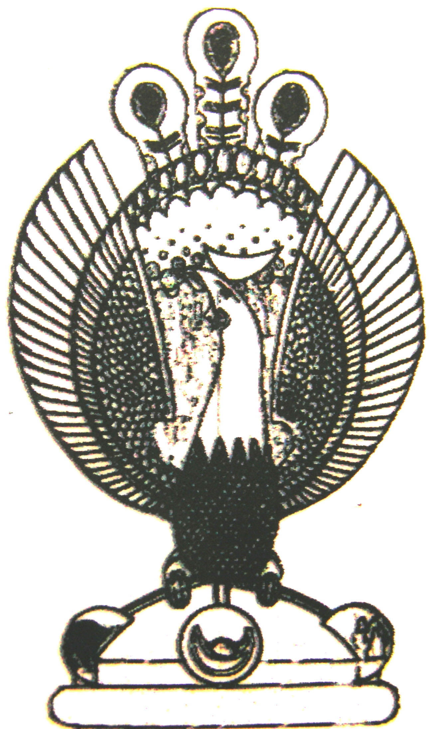

THE HERITAGE

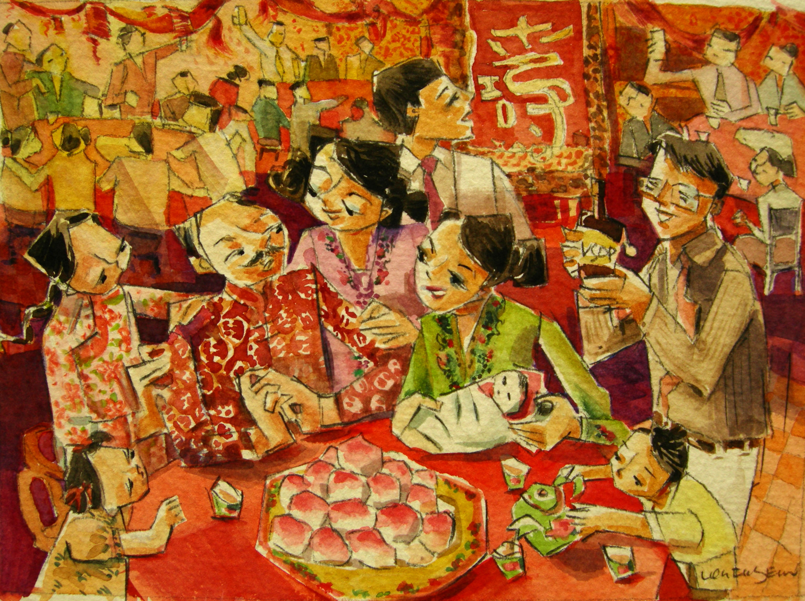
The Peranakan Birthday
The early Peranakans did not believe in yearly birthdays. Only two days in one’s lifetime were worth celebrating, which is one’s first month of life (mua quek, meaning full moon) and
61st birthday

